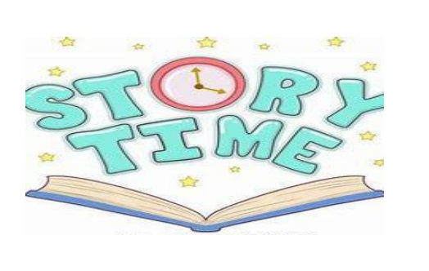

**Let the children come to me……. Matthew 19:14**

**Summer Story Sessions**

**At**

**Morningstar Christian Fellowship**

**79 East Chester Street, Kingston, NY 12401**

**For Kids Ages 3 to 12**

**Fun Time with Games and Snacks**

**When: Saturdays July 13th Through August 17th**

**Time: 10am to 12pm.**

**Register: Please Call or text**

**Les 845-750-1680 or Zee 845-262- 0693**

**Or Email: mscfellowship.office@gmail.com**